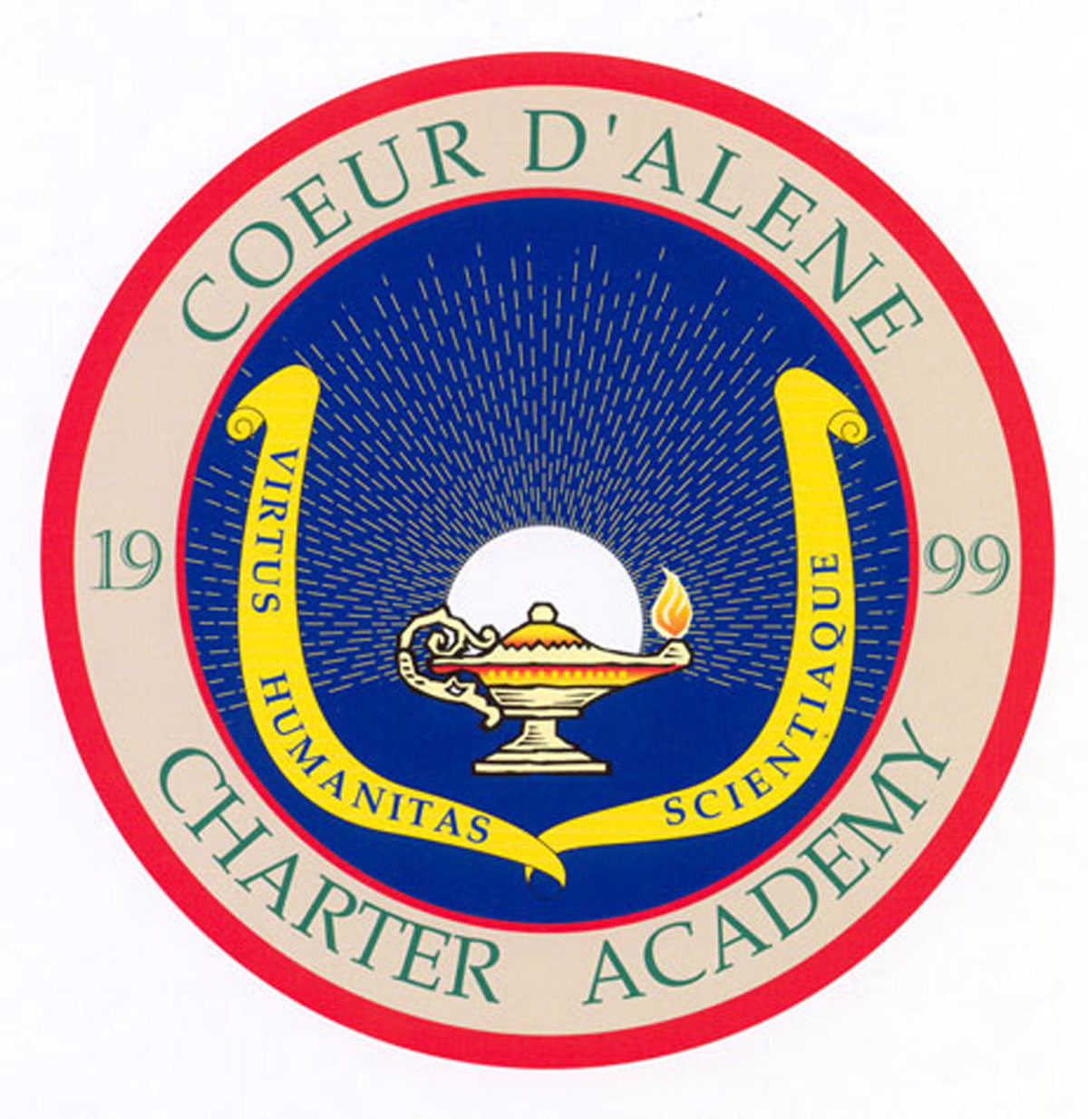
FIELD TRIP
Release and Authorization

I, , natural parent and/or legal guardian of (child’s name), a minor, in consideration of Coeur d’Alene Charter Academy providing for a day trip/field trip on Thursday, February 28, 2013.
Estimated time of departure: 11:40 a.m. Estimated time of return: 1:15 p. m.
Consisting of travel to KROC Center to view CYT’s production of “Alice in Wonderland”. Transportation provided by: Private Vehicle Other
Cost: $5.00 , the same to be supervised by Mrs. Bierne, Mr. Taylor and Parent Chaperones, representing the Coeur d’Alene Charter Academy, do hereby release Coeur d’Alene Charter Academy, its agents, employees, and volunteers, from any and all liability, should there be any injury to my child while in the care of Coeur d’Alene Charter Academy in the endeavor above described.
I further give Coeur d’Alene Charter Academy and its authorized agents or employees the authority to do any action deemed necessary in their judgment in the event they are unable to contact me and there has been an injury, either minor or major, to my child; however, Coeur d’Alene Charter Academy and its agents or employees must exercise their best efforts to contact me in the event an injury is sustained by my child.
I have fully read and understand the contents of this Authorization and Release, and I am signing the same of my own free will.

DATED this __________ day of February , 2013.

Parent/Guardian Signature Emergency Contact Number

Student Signature

